Progress Report

Contextual Visualization of Magnetic Resonance Angiography (MRA)

Farshad Mogharrabi (u1074636)

Karthik Karanth (u1264749)

# Progress

We have completed approximately 50% of the project.

### User Interface:

Initial work on the user interface has commenced. Currently, it supports loading an MHA image of the brain into a VTK-based Python visualization tool. A slider allows the user to control the slice of the image. The next steps are to incorporate ray casting to figure out the region that the user is interested in and expand upon that.

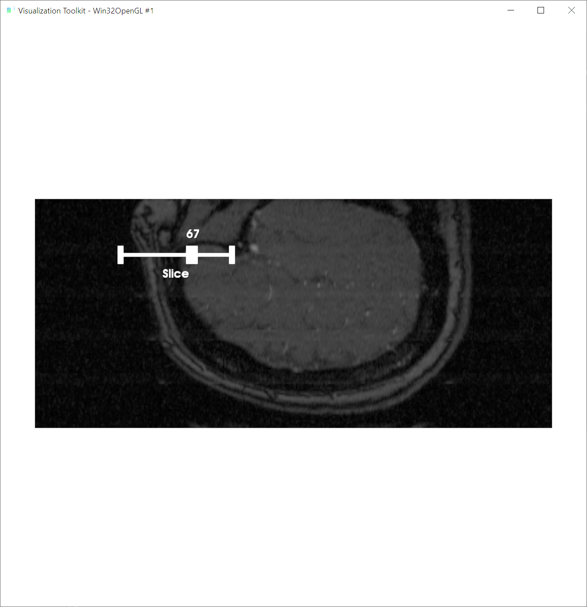

**Figure 1**  our current graphical user interface, capable of changing parameter values over sliders for various filters to be added

### Filtering and processing:

The brain MRA files are scalar fields, and to visualize this data we are using a hybrid combination of slices and volume rendering to best visualize the pattern of distribution of the vasculature. As shown in figure 2, the distribution of values in this type of data is similar to that of many other medical images, with a lot of noise at lower values and then a higher peak for the soft tissue region with a long tail. The blood vessels data resides in the long tail of the histogram, as the blood has distinctive magnetic characteristic compared to other tissues due to high saturation of iron in it. This has been visualized in figure 2 on the right.

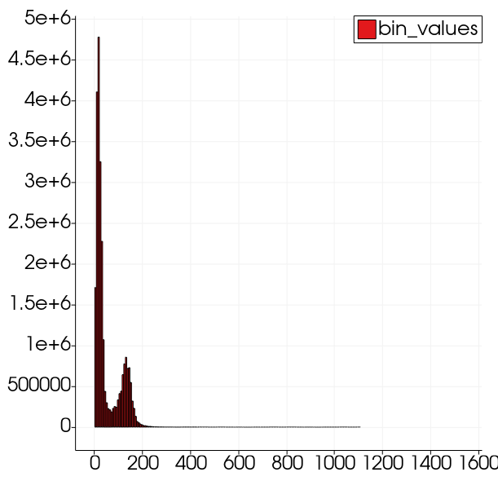 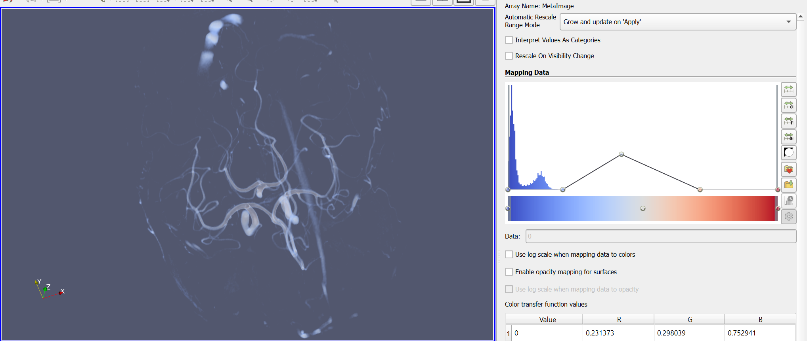

**Figure 2** the data variation of a MRA scalar field visualized (left) and its volume rendering (right)

We now are focusing on extracting the tail region of data in our GUI and show it alongside the slice selected in order to make a 2D-3D hybrid view of the region of interest.

# Steps Toward Completion

**Figure 3** the goal for our visualiztion is to resemble a hybrid view, based on the surgeons opinion

* Adding filters to the GUI
* Adding raycasting to figure out the user’s area of interest
* Using contours to visualize the arterial pathways

We do not expect the above to take significant effort: the main hurdle has been finding good examples/documentation for VTK-python code and we would appreciate any pointers on that.

# Changes Made to The Project Plan

As per the changes in situation regarding meeting with people, and the high work load of medical workers, it is off the table to the university hospital doctor for their feedback on the interface created for evaluating MRA images. However, we are contacting some doctors through online means to get their feedback and iterate through the interface.